Lunch Run Sunday 18th September 2016

A small number of cars met up at the Heartland Hotel and headed to the Bill Richardson Transport World in Invercargill. This is fantastic collection, something for everyone from Trucks, Cars, Wearable Arts costumes and old tools and utensils. Very interesting place and recommend everyone to go have a look.
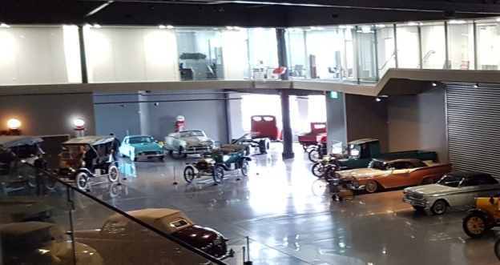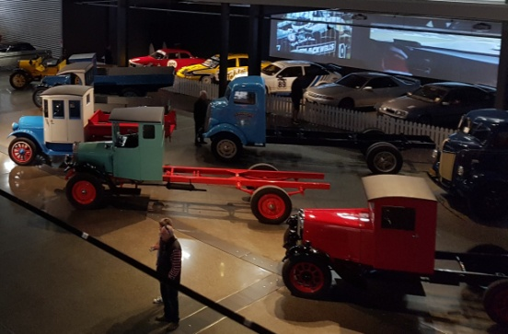
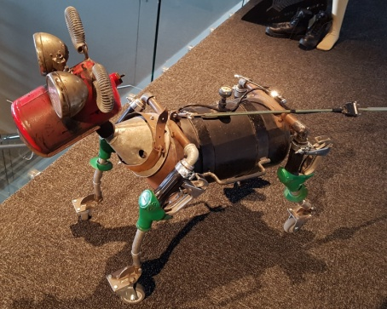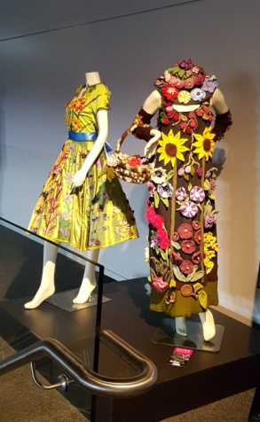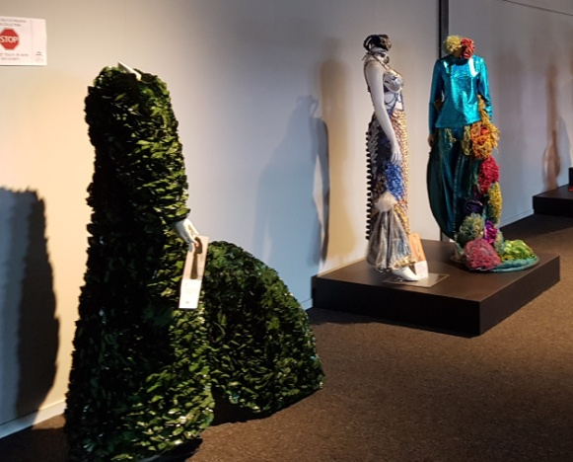
After a couple of hours wandering around the museum we headed to Cobb & Co for some ‘refreshments’ and lunch where the membership was drawn, with Daryl & Maxine Moyles being the lucky winners.

After lunch the few younger ones went on to Stadium Southland to the wall climbing, while the rest of us oldies made our own way home via a few watering holes.

Great day out, a big thanks to Erica Johnstone for organizing this event.

