Xmas Car Run – Saturday 2nd December 2017

We all met at the Lodge on a bright sunny day with our air con on full (all windows down!!) where Kylie had our first game of the day after registration – one member from each car had to twerk, wiggle, jump and shake to get ping pong ball out of a tissue box tied onto their back... made for some funny entertainment and dance moves where usually the kids winning the challenge.

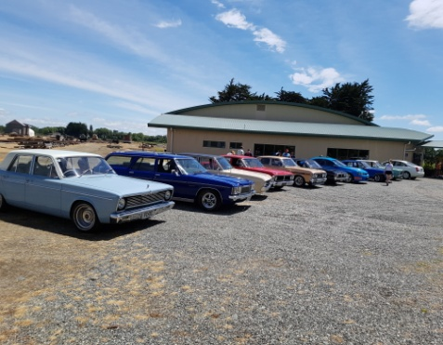
We all then left for the run which took us to places some of us had not been to for a few years, most of us stopped at Mandeville where we tried to get the first challenge of a photo with a train or a plane (who would have thought the train would not be there) was a good photo opportunity of the cars lined up though.

That was where the group went separate ways some heading to Riversdale and others following the map onto Glenmure and Balfour where the kids playground was another photo opportunity. Riversdale and Otama led us onto Waikaka where a quick stop at the pub for refreshments and a chat for some.

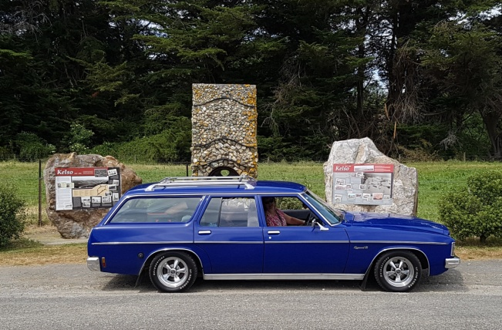
Kelso was the next photo challenge then onto Tapanui where a few cars caught up for a drink. We then headed back to Gore via Pukerau and Kaiwera back roads.

By the time we got back to the racecourse the kids were all enjoying the bouncy castles which kept them entertained until Kylie had a variety of games set up for them to play.

A visit from Santa was the highlight of the day for the kids and they sat very tentatively to receive their parcel.

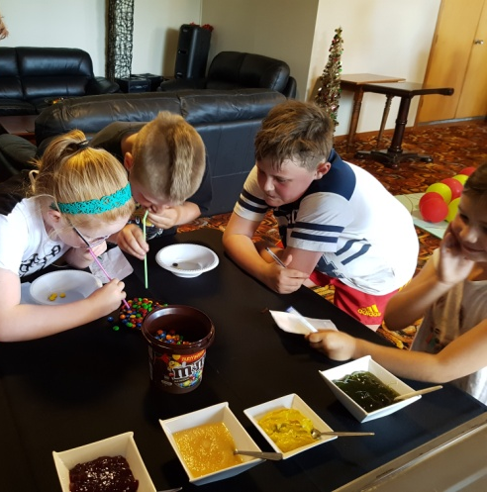 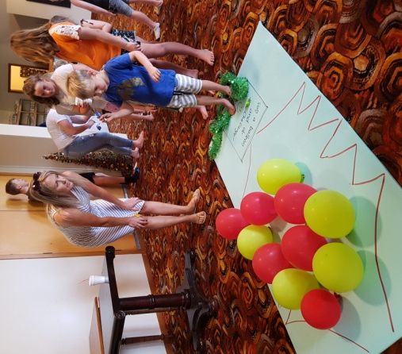.

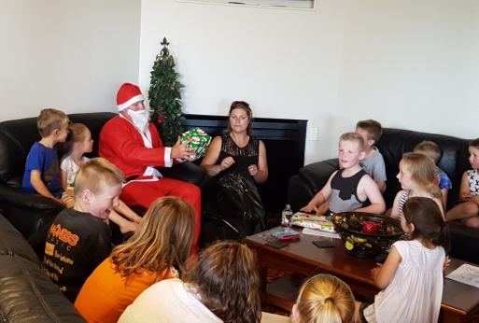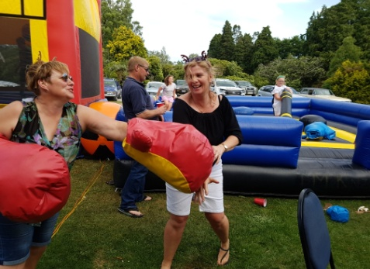

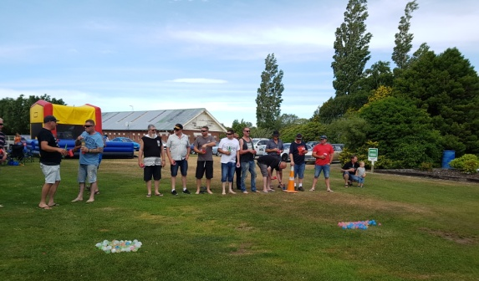
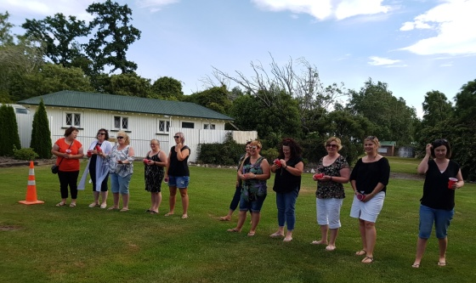
The games weren’t only for the kids; Kylie also had games for the adults to join in involving cups and water balloons. Luckily the males were bad shots and no one actually got too wet.

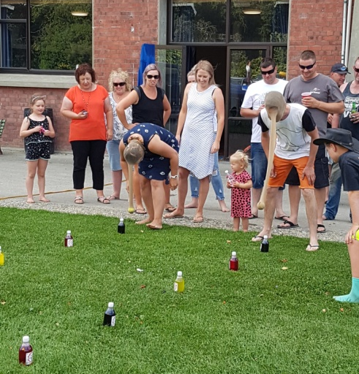
The final game of the afternoon involved stockings, a ball, bottles of fizz and adults crawling along the grass and a fair bit of cheating from both teams ending up in a draw.

If you want a laugh check out the video on our facebook page.

We then went inside and had a terrific buffet meal, after we had all overeaten (typical Xmas dinner) we were lucky it was still a warm evening to sit outside and relax and chat.

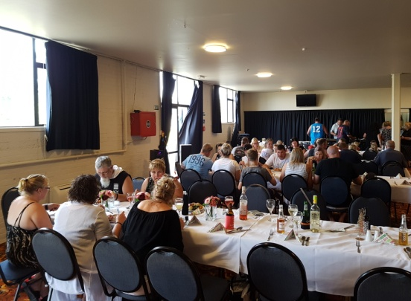
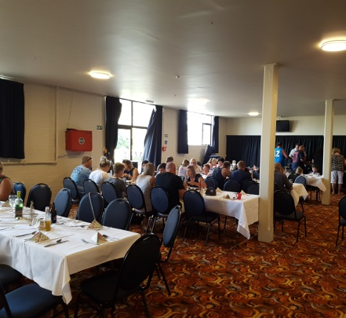
A big thank you to Kylie for organising the day and appreciate all the time that is involved in organising this major event, we all enjoyed the day (well done for organising the great weather too much different to last years weather!!)
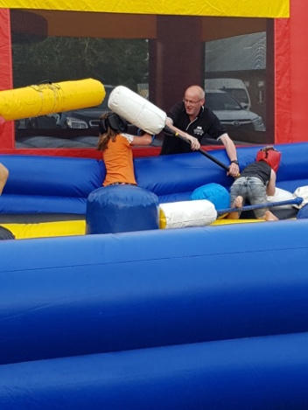
Prize Winners of the day:

Quiz - 1st Peter Haywards car
2nd Mary-Anne Barclays car
Lucky Membership: Russell Paterson
Mug of the Day: Regan (Bushy) McLeod for having to be towed home

Hope you all have a Merry Christmas and a safe holiday period!
See you all at the next run next year.

